**First test with thingspeak:**

Send a mqtt message from the desktop using the thingspeak broker to our channel

Tutorial: <https://it.mathworks.com/help/thingspeak/use-desktop-mqtt-client-to-publish-to-a-channel.html>

Pc configuration:

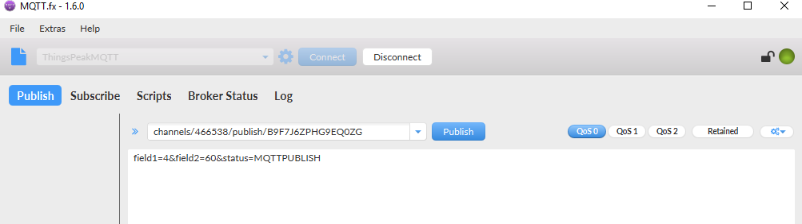

Broker settings:

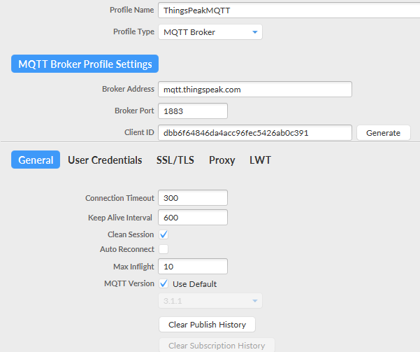

Channel information:

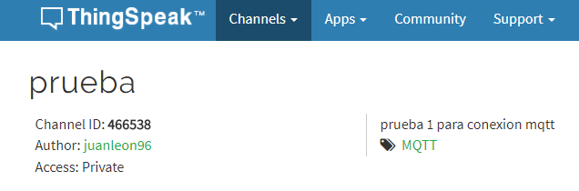

Result:

